  - DH 3264 - Derivatives OTC Customer Phase 1 (NDF)​ – RELEASE 2
  - Business Requirements Document

US PMO Template

Document Version: | 1.0

Originated by: Domingo Megía

Approvers
This document has been approved by the Business Sponsor, or delegate, as the official Business Requirements Document for the project. Following approval of this document, changes will be governed by the project’s change control process, including impact analysis, appropriate reviews and reapprovals.

Business Line | Colleague Name | Colleague Title | Approval email  attachment | Date (MM/DD/YYYY)
Treasury | Ted Fernandez | Treasury – Business Sponsor | 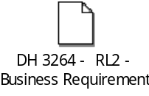 | 12/02/2025

Contributors & Reviewers

Colleague Name | Colleague Title | Business Line
Domingo Megia | Project Manager Lead | Treasury & Markets
Ricardo Valdivia | Product Owner – Treasury | Treasury & Markets

Peer Reviewers
The following Peer Review team members acknowledge the completion of the analysis and discussion of the BRD with the business analyst, and attendance in the Peer Review meeting.
COE Peer Reviewer | Peer Reviewer 1 | Peer Reviewer 2 | Peer Review Meeting Date
NA | NA | NA | NA

Not applicable since this is not an Executive project

Revision History

Version Number | Revision Date  MM/DD/YYYY | Summary of Changes | Revised By
0.1 | 11/10/2025 | Version ready for approval request | Domingo Megia
1.0 | 12/02/2025 | Business Sponsor sign-off attached.  Version ready for uploading in DH. | Domingo Megia

References

Reference # | Document Name | Document
1 | Test Scope Document Release 2 | 

Terms and Definitions

Term | Definition
NDF | Non-deliverable FX Forward contract
RL2 | Release 2 of project DH 3264 – Derivatives OTC Customer Phase 1

Table of Contents
1 Project Summary 8
1.1 Project Background and Overview 8
1.2 Assumptions/Dependencies/Constraints 8
1.2.1 Requirements Assumptions & Dependencies 8
1.2.2 Project Constraints 9
1.3 Out of Scope 10
1.4 Business/Customer/Channel Impact 11
2 Current and Future States 11
2.1. Current State 11
2.2 Future State 11
3 Requirements 12
3.1 Business Requirements 12
4 Non-Functional Requirements 13
4.1 Security 13
4.2 Data Governance 13
4.3 Auditability 13
4.4 End User Ease of Usability 13
4.5 Performance Efficiency 13
4.6 Scalability 13
4.7 Reliability 13
4.8 Business User Maintainability 14
4.9 Backup and Recovery 14
4.10 Availability 15

Project Summary

Project Background and Overview

The objective is to add Non-Deliverable FX Forward contracts (NDFs) to our current client offerings in BSI Miami. An NDF is a cash-settled foreign-exchange forward contract in which the two currencies are not exchanged at maturity (hence "non-deliverable"). On the settlement date, the counterparties settle the difference between the contracted NDF price and the prevailing spot price. The profit or loss is calculated on the notional amount of the agreement by taking the difference between the agreed-upon rate and the spot rate at the time of settlement.

In release two of this project, this document is in relation to, BSI only aims to incorporate new functionalities /minor enhancements for the e2e process. They are all related to T24 NDF module.

All the sections below are filled in based on Release 2 scope.

Assumptions/Dependencies/Constraints

Requirements Assumptions & Dependencies
                - Overall Scope:
- Entities: Banco Santander International Miami (BSI).
- Product: Non-Delivery Forward (NDF).
- Currencies:
- Colombia (COP) – USD
- Chile (CLP) – USD
- Argentina (ARS) – USD
- Brazil (BRL) – USD
- Perú (PEN) – USD

                - Systems:
- T24 NDFs Module R11. This release only affect T24 module.

                - Stream Scope :
- Pre-trade checks.
- Tax Wittholding
- Reports

                - The requirements in this BRD have the following assumptions and dependencies:
- Assumption or Dependency? | - Related Requirement Number | - Note the Assumption or Dependency
- A1 | - 1,2,3 | - There is a release 1 where main features of the products are deployed.
- A2 | - 3 | - Main features of reports are deployed as part of release 1

Project Constraints

                - The project has the following constraints:
- Number [C#] | - Constraint
- C1 | - Dependency on existing system capabilities

Out of Scope
The following components are out of scope of this BRD:

- Number | - Out of Scope Item
- OOS1 | - Improvements in FX product functionalities not requested in this document.
- OOS2 | - Requirements implemented in release 1 of this project

1.4 Business/Customer/Channel Impact

Business/Customer/Channel | Impact Description
Order booking | This release will incorporate new pre-trade check that will impact in the process for inserting NDF orders.
Tax application / Regulatory reporting | This release will incorporate all requirements regarding Withholding so application and refund to clients will be allowed after this implementation and also, data from this action will be reported to the regulator.

Current and Future States

Current State

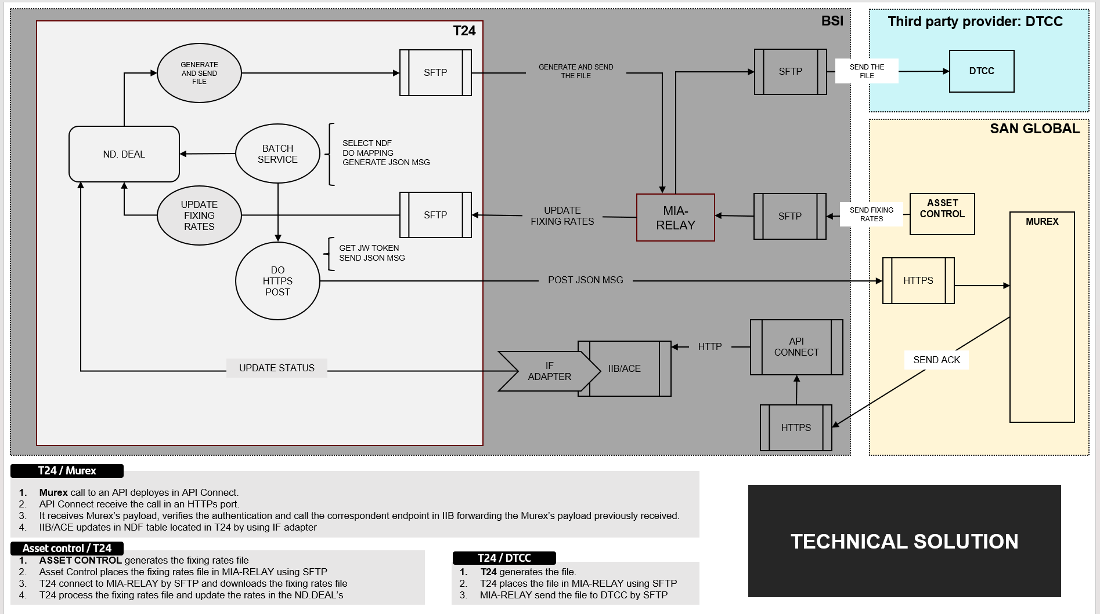

Future State
Same State as current one above. This release 2 does not modify architecture of solution.

Requirements

Business Requirements
The table below presents the following information:
- BR #: Unique high level requirement identifier
- DR #: Unique detailed requirement identifier
- Requirement Description: Requirement text
- Scope ID: Related ID from the Scope Document
- Priority: Implementation priority for each requirement based on MoSCoW prioritization
- Phase: Project phase during which the requirement is expected to be implemented

BR # | Requirement Description | Scope ID | Priority | Release
BR 1 | Pre trade checks | 1 | 1 | 2
BR 2 | Tax Withholding | 2 | 1 | 2
BR 3 | BBG to T24 connectivity recon (T24 report update) | 3 | 2 | 2
BR 4 | Annual Financial report | 3 | 1 | 2

BR1 – Pre- Trade checks:

Max maturity of two years
- Background: NDF risk exposure and liquidity is fully unknown beyond 2-years horizon so a limitation in its trading should be done to avoid incurring in very high risks. BSI will not enter NDFs with a stated maturity greater than 2 years.
- Pre-requisite:
- Products in scope for this requirement: NDF & FX Forward
- Requirements: System should not allow order´s input: With more than 2 years of maturity.
  - This pre-trade check only applies to Client deal’s
  - In case, the system detects that the order has a maturity over 2 years a soft block should be triggered with the following pop-up message: “Max maturity of 2 years exceeded”
  - Afterwards, the order can be executed by the trader.

Fin Knowledge and Valid Client´s profile
- Background: BSI clients have their own financial knowledge and Client´s profile that determines if a particular strategy of trading is suitable for them.

- Pre-requisite:

- Products in scope for this requirement: NDF & FX Forward
- Requirements:
- This pre-trade check only applies to Client deal’s
- System should not allow order´s input for Clients with
  - With Financial Knowledge = “NO” AND/OR
  - With invalid client profile (Valid profiles: Conservative, moderate and Aggressive)
If any of the conditions above are meet, then system should block the order (Hard Block) with the following pop-up message: “The order does not meet the Financial Knowledge and Valid Client´s profile requirements”
Note that, afterwards, it shouldn’t be possible to input the deal in the system, with no exceptions, unless client data record is update accordingly. If so, this task should be triggered by the banker (out of our scope) to request a change for existing BAU processes for this purposes.

Dood Frank Swap Dealer check:
- Background:
- Under the Dodd-Frank Act, entities that engage in swap dealing activity over $8 billion notional (commonly referred to as the “de minimis threshold”), need to register as a “swap dealer” with the CFTC. The only entity in Santander Group registered as “swap dealer” is Santander SA so all other entities within the Group must maintain its swaps activity below the de minimis threshold.
- RAC Global team monitor this consumption using “DFA De Minimis Threshold monitoring procedure” SBNA has developed a monitoring program to ensure compliance with the de minimis threshold. BSI needs to work with SBNA to expand the existing program to account for BSI’s trading activity.
- 1Bn out of 8Bn limit has been allocated for OTC derivatives trading across BPI. BPI cannot exceed this 1Bn limit to ensure Santander Group complies with the DFA regulation.
- Pre-requisite:
- Local allocation of $1Bn to BSI Miami.
- Systems have capabilities to calculate simulated total consumption by all BPI entities/branch
- Requirements:
- For each order´s input, the solution in place should be able to simulate its consumption of DFA de minimis threshold and then add this consumption to existing one to obtain TOTAL consumption of lives positions.

- Logic of Calculation: Adding of all notional open during the full last year considering the period of 365 days immediately before the day when the pre-trade check is being executed.
For hedging, the defined logic is that if the hedge of the local BSI customer is covered by SBNA/Banco Santander or any branch/subsidiary of the bank, then it is an intragroup transaction and is therefore not included (only the customer's transaction is counted). On the other hand, if the hedge is with an external bank, both the customer's part and the counterparty's part must be accounted for. This is the number of transactions against customers that meet this criterion.
- According to the calculation of total consumption:
      - If simulation result > threshold, then the order is blocked (hard block)
      - If simulation result <= threshold, then then the order can continue – pass.

BR2 – Tax Withholding
All related requirements are fully described in the attachment below:
- Requirement:
- Withholding, as detailed below, on the GROSS AMOUNT IN USD (payment amount) applies to Individual and Entity Customers with Expired or Rejected IRS Tax W Forms W-8 (W-8BEN and W-8IMY only) and W-9. (These Customers [which are a subset of the full population] are otherwise referred to as Undocumented Individuals and Entities and would currently have US.TAX.FORMS of NUSNW8, NUSFATCA or USFATCA although USFATCA will be replaced with USNW8 in the Redesigned DEFINE.TAX once put into production.)
  - Withholding for NUSNW8 of 24% must route to General Ledger USD162010001
  - Withholding for NUSFATCA of 24% must route to General Ledger USD162010001
  - Withholding for USFATCA of 24% must route to General Ledger USD162010001
- A new Income Type for NON-DELIVERABLE FORWARDS is required.
- All Non-Deliverable Forward payments received by ALL Customers should be mapped to FATCA’s Withholding Report with all the required information including the respective withholding, when applied.
  - The COUNTRY OF INCORPORATION for all Non-Deliverable Forward payments on the Withholding Report should be MULT
  - The IRS TAX W FORM brought into the Withholding Report, in general, including for Non-Deliverable Forwards, should be that of the First Party. This will ensure that for Joint Accounts documented with both a W-9 and W-8BEN, the Customer is considered W-9.
  - Automatic Reimbursement of withholding via the Reimbursement Report is also required when the previously Undocumented Customer becomes Documented with a valid IRS Tax W Form W-8BEN or W-8IMY during the same calendar year and the US.TAX.FORM changes accordingly.
    - CLARIFICATIONS AND EXCEPTIONS:
      - Customers who become documented with a valid IRS Tax W Form W-9 (First Party) should NOT be reimbursed.
      - W-8IMY:
        - When a W-8IMY becomes documented and ALL underlying PTN, BO, STR or SH are documented with an IRS T W Form W-9 linked to the W-8IMY AH Party, there should also be NO reimbursement.
        - If there are one or more underlying PTN, BO, STR or SH documented with an IRS T W Form W-8 (any kind) linked to the W-8IMY AH Party, reimbursement SHOULD take place given Development Limitations below:
          - FOR DISCUSSION DEVELOPMENT LIMITATIONS: If there are one or more underlying PTN, BO, STR or SH documented with an IRS T W Form W-9 and IRS T W Form W-8 linked to the W-8IMY AH Party, reimbursement should only take place for the portion documented with a W-8.

IT should determine if there are any other requirements to achieve the above objectives.
2 Where the client makes an NDF payment rather than receiving a payment, we wouldn’t expect any information to flow to the Withholding Report
BR3 – BBG to T24 connectivity recon (T24 report update)
Background for this req:
- Currently, MO has a query in the T24 menu called “FX RECON” from which you can see all the FX that have been entered into T24 on that day. Within the screen, there is a DEAL.TYPE column that shows all FX types except NDF.
- In addition to this, MO will ask Bloomberg to add a new Fixing date column for NDF.
Requirement description:
- For MO's daily review in T24, IT must add two elements to the “FX RECON” query:
- Include NDF in the PRODUCT.TYPE column inside the query.
- Include a new column with the fixing date, shown as “FIXING.DATE”.
                - Modify label´s name as of instruction from stakeholders

                - BR 4 - Annual Financial report
- Background: Non-Deliverable Forwards (NDFs) are Forex products that must be included in the Annual Financial Summary for Tax Purposes once settled. Although NDF belongs to the Forex product family, it has specific characteristics (e.g., fixing rate) and potential tax implications that justify differentiated a new section in the report for this product.
- Pre-requisite: NA
- Requirements:
- The Annual Financial report must include all NDF transactions with settlement date within the reported fiscal year. Settlement date is the key driver (no trade date or any other date)
- Only transactions related to the specific client must appear in that client’s report. This means that report is at client level.
- A new, dedicated table for NDF must be created in the report (the existing Forex table must not be modified). The new NDF table must include, at minimum:
- Trade Date
- Fixing date
- Settlement Date
- Notional
- Currency bought
- Amount bought
- Currency sold
- Amount sold
- Fixing Rate
- Settlement Amount
- Trade ID

Note, as there wasn’t any settlement in 2025, and the first settlement will happen in 2026, the first Annual finnacial report with this new column for NDF will be done in January 2027 report (covering settlements in 2026).

- Disclosure: a Non-Deliverable Forward (NDF) is a cash-settled, short-term over-the-counter (OTC) foreign exchange forward contract used primarily for currencies that are not freely convertible or are restricted by regulations. Unlike traditional forwards, there is no physical exchange of the principal amounts at maturity; instead, parties settle the difference between the contracted NDF rate and the prevailing spot rate, usually in US dollars (USD). OTC derivatives are complex financial instruments and may involve significant leverage, counterparty exposure, liquidity risk, and potential losses exceeding initial expectations.
4. Non-Functional Requirements

Security

Req # | Requirement
4.1.1 | Project should comply with all security requirements defined by Infosec

Data Governance

Req # | Requirement
NA | NA

Auditability

Req # | Requirement
NA | NA

End User Ease of Usability

Req # | Requirement
NA | NA

Performance Efficiency

Req # | Requirement
NA | NA

Scalability

Req # | Requirement
NA | NA

Reliability

Req # | Requirement
NA | NA

Business User Maintainability

Req # | Requirement
NA | NA

Backup and Recovery
Req # | Requirement
4.9.1 | Recovery Time Objective shall be 0 - 8 hours
4.9.2 | Recovery Point Objective shall 0 – 4 hours
4.9.3 | Recovery environment shall have sufficient capacity to support production workload

4.10 Availability

Req # | Requirement
4.10.1 | System should be available to access any time except for COB running.  System should be recovery between 0-4 hours.  Unavailability means, users cannot access to T24 to facilitate NDF trading to the client.

Table 1. Unavailability timeframes allowed for each Availability requirement
Availability of…  Means… | 99.95% | 99.90% | 99.50% | 98.00% | 95.00%
Daily downtime of | 43.2s | 1m 26.4s | 7m 12.0s | 28m 48.0s | 1h 12m 0.0s
Weekly downtime of | 5m 2.4s | 10m 4.8s | 50m 24.0s | 3h 21m 36.0s | 8h 24m 0.0s
Monthly downtime of | 21m 54.9s | 43m 49.7s | 3h 39m 8.7s | 14h 36m 34.9s | 1d 12h 31m 27.3s
Yearly downtime of | 4h 22m 58.5s | 8h 45m 57.0s | 1d 19h 49m 44.8s | 7d 7h 18m 59.0s | 18d 6h 17m 27.6s

IT should determine if there are any other requirements to achieve the above objectives.
.

